***Items Needed to Perform Update***

* A Windows Operating System PC (Windows 7 and up)
* Spektrum SPMXCA200 Avian & Firma Smart ESC Programming Box (sold separately)
* Spektrum Firma Smart ESC SPMXSE1160 (Retail Version / DBXL-E 2.0) or SPMXSE1160CP (ARRMA Kraton 8S ESC)
* Spektrum Firma Smart ESC SPMXSE1150 (Retail Version)
* Spektrum Firma Smart ESC SPMXSE1130 (Retail Version / Losi Tenacity DB Pro)

***Step by Step***

Download the latest Firma 160A CP (**SPMXSE1160CP** – Kraton 8S) Smart ESC firmware updater here [(link)](https://www.horizonhobby.com/pdf/Firma_160_CP_ARRMA_Kraton_8S_Smartlink_App_and_Updater_VB309.zip)

Download the latest Firma 160A (**SPMXSE1160** – Retail Version / DBXLE) Smart ESC firmware updater here [(link)](https://www.horizonhobby.com/pdf/Firma_ESC_Open_Stock_Smartlink_app_and_updater.zip)

Download the latest Firma 130A (**SPMXSE1130** – Retail Version / Losi Tenacity DB Pro) Smart ESC firmware updater here[(link)](https://www.horizonhobby.com/pdf/Firma_ESC_Open_Stock_Smartlink_app_and_updater.zip)

Download the latest Firma 150A (**SPMXSE1150** – Retail Version) firmware updater here [(link)](https://www.horizonhobby.com/pdf/Firma_ESC_Open_Stock_Smartlink_app_and_updater.zip)

Once downloaded extract the .ZIP file to a location that you can easily find, we suggest the Desktop

Locate the Spektrum USB Link application and open the file: 

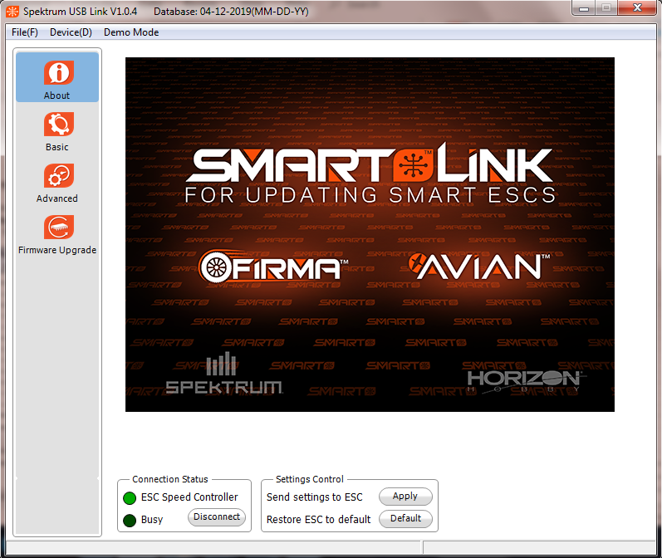You will be presented with this screen:

* Plug the appropriate battery source into your Firma ESC to power on
* Connect the SPMXCA200 programmer to the Firma ESC through the fan port with the included three wire servo cable
* Connect the SPMXCA200 programmer to your PC via the included USB cable
* Power on your Firma ESC to connect the ESC to the Spektrum USB Link application
* Click the Firmware Upgrade tab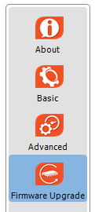
* Select the top version from the “Available Versions” drop down box then click the “Upgrade” button to perform the update
* 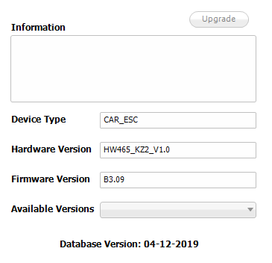

Once the **Upgrade** button has been selected to install the update on your Firma ESC a progress bar will appear on your computer screen. Please allow the update to completely finish then click OK to save the settings. You can disconnect and use your Firma ESC with the improved Firmware now.

## Change Log

Firma 160A SPMXSE1160 -- Open Stock / DBXL-E 2.0 Firmware: **B4.06**

1. Improves braking action
2. Improves reverse action

Firma 160A SPMXSE1160CP -- Kraton 8S Firmware: **B3.09**

1. Improve acceleration power

Firma 150A SPMXSE1150 – Retail Version Firmware: **B2.11 (off-road) B2.12 (on-road)**

1. Improve acceleration power

Firma 130A SPMXSE1130 – Retail Version / Losi Tenacity DB Pro Firmware: **B1.58**

1. Improve acceleration power

Firma 160A SPMXSE1160 -- Open Stock / DBXL-E 2.0 Firmware: B4.02

* Initial production version

Firma 160A SPMXSE1160CP – Kraton 8S Firmware: B3.02

* Initial production version

Firma 150A SPMXSE1150 – Retail Version Firmware: B3.03

* Initial production version

Firma 130A SPMXSE1130 – Retail Version / Losi Tenacity DB Pro Firmware 1.53

* Initial production version